## Making your class directory the default start-up directory for R Studio

A few people have asked about this, and there’s a pretty simple way to bypass the whole issue of having to set the working directory every time you start a session with R Studio.

By default, when you installed R Studio, it sets a Home directory and that is the directory that shows up in the files panel when you start a new session.

You can establish your own startup directory as follows:

In R Studio, choose **Tools > Global Options**. This opens a dialog that looks like this (Windows version):

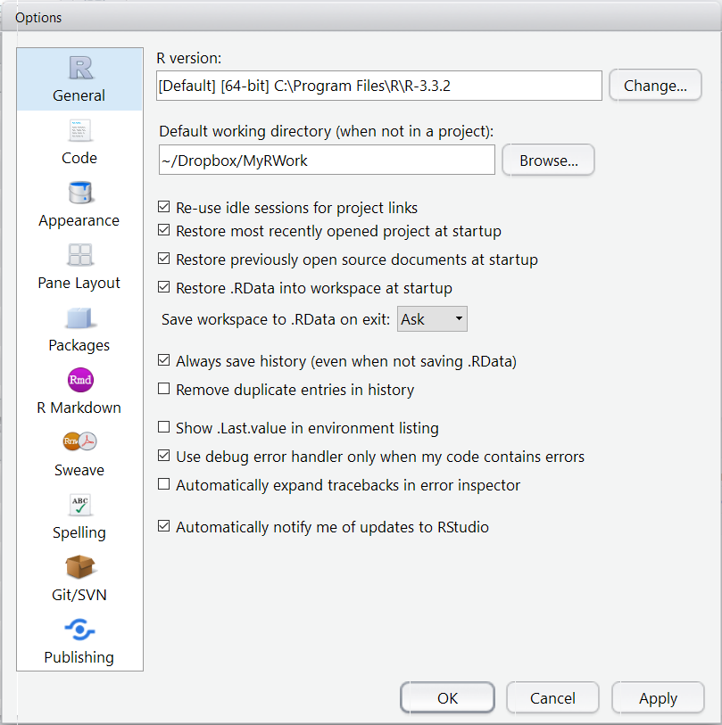

Click **Browse** next to **Default working directory….** Navigate to your preferred working directory.

Click **OK**, and from now onward, each time you start RStudio, you’ll be in your working directory.

That’s it!